PRACTICAL-1

NAME: P. ANURADHA NANDINI
ROLL NUMBER: 2520030171
SECTION: 08
Title:
Implementation of Process Creation and Command Execution in Linux using fork(), exec(), and wait() System Calls
Aim:
To develop a C program that accepts a Linux command from the user, creates a child process using fork(), executes the command using the exec() system call, waits for the child process using wait(), and displays the Process IDs (PIDs) of both parent and child processes.
Objective: • To understand process creation in Linux.
• To learn how fork() creates a child process.
• To execute Linux commands using the exec() family of system calls.
• To synchronize parent and child processes using wait().
• To observe the Process IDs (PIDs) of parent and child processes.
Theory:
Linux is a multitasking operating system that executes multiple processes simultaneously. Every running program in Linux is known as a process and is identified by a unique Process ID (PID).
The operating system provides several system calls to manage processes:
- fork():
• Creates a new child process.
• The child process is an exact copy of the parent.
• Returns:
• 0 to the child process.
• Child PID to the parent process.
• -1 if creation fails.
- exec():
The exec() family replaces the current process image with a new program. Common functions are:
• execl()
• execv()
• execlp()
• execvp()
In this experiment, the child process executes the user-entered Linux command.
- wait():
The parent process waits until the child process finishes execution. This prevents zombie processes.

Algorithm:
1. Start the program.
2. Accept a Linux command from the user.
3. Create a child process using fork().
4. If child process:
• Execute the command using execlp() or execvp().
If parent process:
• Wait for the child process using wait().
5. Display Parent PID and Child PID.
6. Stop.

System Calls Used:
System Call | Purpose
Fork() | Creates a child process
exec() | Executes a Linux command
wait() | Waits for child process
getpid() | Returns current process ID
getppid() | Returns parent process ID

Observation:
• A child process was successfully created using the fork() system call.
• The child process executed the user-entered Linux command using the exec() system call.
• The parent process waited until the child completed execution using the wait() system call.
• Different Process IDs (PIDs) were displayed for both parent and child processes.
• The experiment demonstrated how Linux creates and manages processes.
Result:
The program was successfully executed. The Linux command entered by the user was executed through a child process. The parent process waited for the child process to complete execution, and the Process IDs of both parent and child were displayed
successfully.
Part 2: Linux Commands Observation
Aim:
To investigate the relationship between hardware resources and operating system services using Linux terminal commands.
1. uname:
Purpose: Displays information about the Linux operating system.
Observation: Shows the kernel name and version of the operating system.
2. lscpu:
Purpose: Displays CPU architecture and processor details.
Observation: Provides information about CPU model, cores, threads, cache size, and architecture.
3. lsblk:
Purpose: Lists storage devices connected to the system.
Observation: Displays hard disks, SSDs, partitions, and mounted storage devices.
4 .ps:
Purpose: Displays currently running processes.
Observation: Shows Process IDs (PIDs), terminal information, execution time, and running commands.
5. top:
Purpose: Monitors system performance in real time.
Observation: Displays CPU usage, memory usage, running processes, and system load dynamically.
Hardware and OS Relationship:
CPU: The operating system schedules CPU time among multiple processes using the CPU scheduler, ensuring efficient execution.
Memory: The operating system manages RAM allocation and deallocation, preventing conflicts between processes through virtual memory and memory protection.
Storage: The operating system manages files, directories, and storage devices using the file system, allowing users to store and retrieve data efficiently.
Input/Output Devices: The operating system communicates with hardware devices such as keyboards, mice, printers, and disks using device drivers.

Conclusion:
The experiment successfully demonstrated Linux process creation, execution, and synchronization using fork(), exec(), and wait(). It also showed how Linux commands provide detailed information about CPU, memory, storage, and running processes, illustrating the operating system's role in managing hardware resources.
Code:
#include<stdio.h>
#include<unistd.h>
int main()
{
int fd[2];
char buf[100];
printf("Enter a command:\n");
read(0,buf,100);
int pid;
pid=fork();
if(pid==0)
{
printf("\nChild PID:%d\n",getpid());
printf("Parent PID:%d\n",getppid());
execl("/bin/sh", "sh", "-c", buf, NULL);
printf("Execution failed\n");
}
else
{
printf("\nParent PID:%d\n",getpid());
printf("Child PID:%d\n",pid);
printf("\nChild Process completed.\n");
}
}
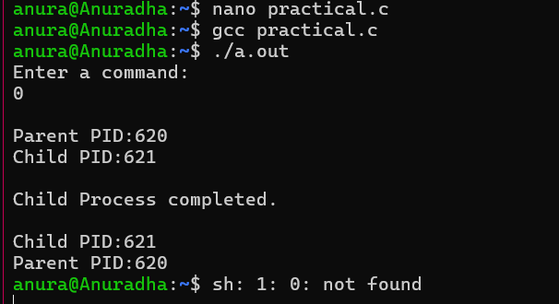
output:

